**UCS 2312 Data Structures Lab**

**Assignment 10: Implementation of Shortest Path Finding algorithm**

**Date of Assignment: 18.11.2023**

The cityADT contains the number of cities and the connectivity information between the cities (adjacency matrix). Write the following methods. [CO2, K3]

* void create(cityADT *C) – will represent the graph using adjacency matrix
* void disp(cityADT *C) – Display the graph
* void Dijkstra(cityADT *C) – Displays the intermediate and final tables
* char * displayPath(cityADT *C, source, destination) – Find the path of the intermediate cities between the source and destination cities along with the cost

**Data Structure – Graph:**

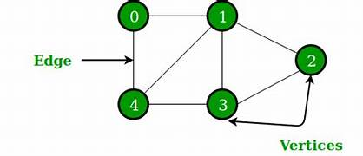

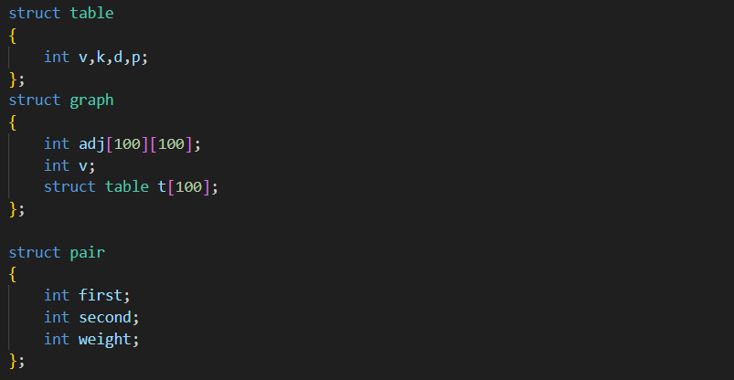

**Algorithm –**

**Algorithm: will create the graph using adjacency matrix**

Input – Pointer to Graph, no. of vertices, no. of edges, array of pairs

Output – void

1. G->v=v
2. for(i=0;i<e;i++)

if directed graph

G->adj[pairs[i].first][pairs[i].second]=1

else

G->adj[pairs[i].first][pairs[i].second]=1

G->adj[pairs[i].second][pairs[i].first]=1

**Algorithm: display the adjacency matrix**

Input – Pointer to Graph

Output – void

1. i=1 and j=1
2. while(i<=G->v)

while(j<=G->v)

print G->adj[i][j]

print a new line

**Algorithm: Displays the intermediate and final tables**

Input – Pointer to Graph, starting vertex x

Output – void

1. while(there is an unknown vertex)

print table

vertex v=smallest dist unknown vertex

v.known=true

for each vertex w adjacent to v

if(!w.known)

c=cost of edge from v to w

if(distance v + c < distance w)

distance w=distance v + c

path w=v

**Algorithm: Find the path of the intermediate cities between the source and destination cities along with the cost**

Input – Pointer to Graph, destination vertex v

Output – void

1. if(path v != -1)

path(G,path v)

1. print v

**queue.h code:**

struct queue{

int arr[100];

int size;

int front, rear;

};

void createQueue(struct queue* q, int size){

q->size = size;

q->front = q->rear = -1;

}

int isQueueFull(struct queue* q){

if(q->rear + 1 >= q->size) return 1;

else return 0;

}

int isQueueEmpty(struct queue* q){

if(q->rear == -1 && q->front == -1) return 1;

else if(q->front > q->rear){

q->front = q->rear = -1;

return 1;

}

else return 0;

}

void enqueue(struct queue* q, int data){

if(isQueueFull(q)){

printf("\nQueue is full");

}

else{

if(q->rear == -1){

q->front++;

}

q->rear++;

q->arr[q->rear] = data;

}

}

int dequeue(struct queue* q){

if(isQueueEmpty(q)){

printf("\nQueue is empty");

return -1;

}

else{

int data = q->arr[q->front];

q->front++;

return data;

}

}

**stack.h code:**

struct stack{

int arr[100];

int size;

int top;

};

void createStack(struct stack *s, int size){

s->size = size;

s->top = -1;

}

int isStackEmpty(struct stack *s){

if(s->top == -1) return 1;

else return 0;

}

int isStackFull(struct stack *s){

if(s->top + 1 >= s->size) return 1;

else return 0;

}

void push(struct stack *s, int data){

if(isStackFull(s)){

printf("\nStack is Full");

}

else{

s->top += 1;

s->arr[s->top] = data;

}

}

int pop(struct stack *s){

if(isStackEmpty(s)){

return -1;

}

else{

int val = s->arr[s->top];

s->top -= 1;

return val;

}

}

int peek(struct stack *s){

if(isStackEmpty(s)){

return -1;

}

else{

return s->arr[s->top];

}

}

**graph.h code:**

#include "stack.h"

#include "queue.h"

struct table

{

int v,k,d,p;

};

struct graph

{

int adj[100][100];

int v;

struct table t[100];

};

struct pair

{

int first;

int second;

int weight;

};

void create(struct graph *G, int v, int e, struct pair pairs[])

{

G->v=v;

for(int i=0;i<e;i++)

{

G->adj[pairs[i].first][pairs[i].second]=pairs[i].weight;

}

}

void display(struct graph *G)

{

printf(" ");

for(int i=1;i<=G->v;i++)

printf("%c ",(char)(i+64));

printf("\n");

for(int i=1;i<=G->v;i++)

{

printf("%c ",(char)(i+64));

for(int j=1;j<=G->v;j++)

{

printf("%d ",G->adj[i][j]);

}

printf("\n");

}

}

void visit(int vis[], int x)

{

vis[x]=1;

printf("%d ",x);

}

void BFS(struct graph *G, int x)

{

struct queue *Q=(struct queue*)malloc(sizeof(struct queue));

createQueue(Q,G->v);

int vis[G->v+1];

visit(vis,x);

enqueue(Q,x);

while(!isQueueEmpty(Q))

{

int z=dequeue(Q);

for(int i=1;i<=G->v;i++)

{

if(G->adj[z][i] == 1 && vis[i]!=1)

{

visit(vis,i);

enqueue(Q,i);

}

}

}

}

void DFS(struct graph *G, int x)

{

struct stack *S=(struct stack*)malloc(sizeof(struct stack));

createStack(S,G->v);

int visit[G->v+1];

visit[x]=1;

printf("%d ",x);

push(S,x);

while(!isStackEmpty(S))

{

for(int i=1;i<=G->v;i++)

{

int t=peek(S);

if(G->adj[t][i] == 1 && visit[i]!=1)

{

visit[i]=1;

push(S,i);

printf("%d ",i);

}

}

pop(S);

}

}

**dijkstra.h code:**

#include "graph.h"

void init(struct graph *G)

{

for(int i=1;i<=G->v;i++)

{

G->t[i].k=0;

G->t[i].d=999;

G->t[i].p=-1;

G->t[i].v=i;

}

}

void printTable(struct graph *G)

{

printf("\n\nV K D P");

for(int i=1;i<=G->v;i++)

{

printf("\n%d %d %d %d",G->t[i].v,G->t[i].k,G->t[i].d,G->t[i].p);

}

}

int check(struct graph *G)

{

for(int i=1;i<=G->v;i++)

{

if(G->t[i].k==0)

return 1;

}

return 0;

}

int minimum(struct graph *G)

{

int min=999;

int v=-1;

for(int i=1;i<=G->v;i++)

{

if(G->t[i].d<min && G->t[i].k==0)

{

min=G->t[i].d;

v=i;

}

}

return v;

}

void dijkstra(struct graph *G, int s)

{

init(G);

int v;

G->t[s].d=0;

while(check(G))

{

printTable(G);

v=minimum(G);

G->t[v].k=1;

for(int i=1;i<=G->v;i++)

{

if(G->adj[v][i]!=0 && G->t[i].k==0)

{

if(G->t[i].d>(G->t[v].d + G->adj[v][i]))

{

G->t[i].d=G->t[v].d + G->adj[v][i];

G->t[i].p=v;

}

}

}

}

printTable(G);

}

void path(struct graph *G,int v)

{

if(G->t[v].p!=-1)

{

path(G,G->t[v].p);

printf("->");

}

printf("%c",v+64);

}

**dijkstra.c code:**

#include <stdio.h>

#include <stdlib.h>

#include "dijkstra.h"

void main()

{

int choice=1;

int v,e;

char c;

char first,second;

printf("Vertices = ");

scanf("%d",&v);

printf("Edges = ");

scanf("%d",&e);

printf("Edge pairs:\n");

struct pair pairs[e];

for(int i=0;i<e;i++)

{

printf("First, Second Point and distance= ");

while ((c = getchar()) != '\n' && c != EOF) {}

scanf("%c %c %d",&first,&second,&pairs[i].weight);

pairs[i].first=(int)first-64;

pairs[i].second=(int)second-64;

}

struct graph *G=(struct graph*)malloc(sizeof(struct graph));

create(G, v, e, pairs);

display(G);

char x;

printf("Staring point = ");

while ((c = getchar()) != '\n' && c != EOF) {}

scanf("%c",&x);

printf("\n");

dijkstra(G,(int)x-64);

printf("\n");

printf("Destination = ");

while ((c = getchar()) != '\n' && c != EOF) {}

scanf("%c",&x);

path(G,(int)x-64);

printf("\n");

}

**Output Screen:**

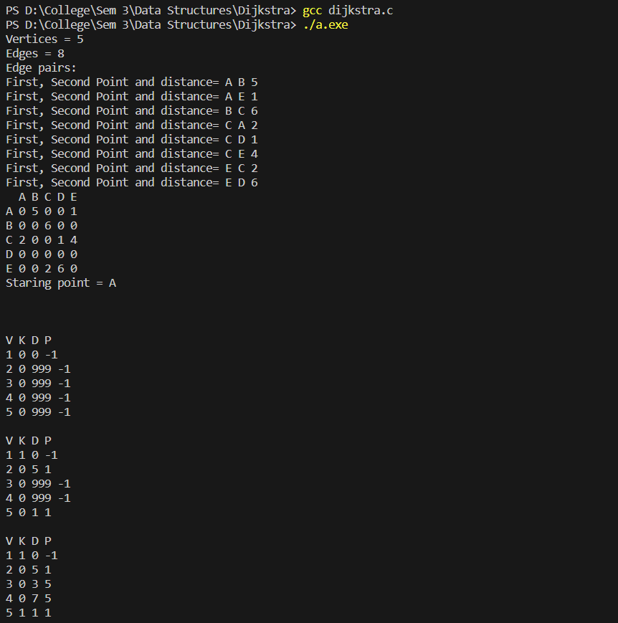

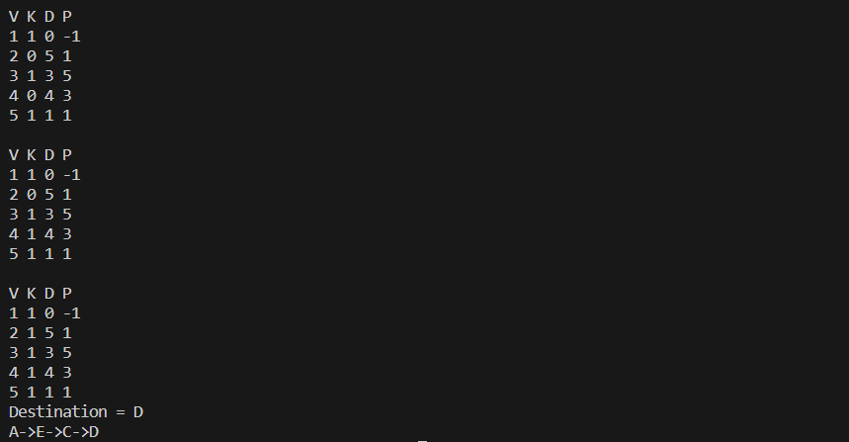

**Learning Outcome:**

